**Md. Rakib- Ul- Alam**

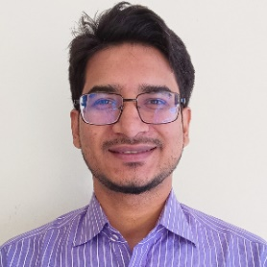**Trainee**

Batch Id: 1286970 Round: 64

Contact: 01773337581Email: alamrakib096@gmail.com

**Objective:**

Motivated professional with a degree in English and a strong passion for technology, currently undergoing specialized training in Web Development under the Islamic Development Bank (IsDB). Eager to leverage my diverse academic background and technical skills to create innovative digital solutions and contribute effectively to dynamic teams.

**Education:**

|  |  |  |
| --- | --- | --- |
| **Degree** | **Year** | **Result** |
| **Masters** | **2021** | **3.13** |
| **Honors** | **2020** | **2.79** |
| **HSC** | **2016** | **4.86** |
| **SSC** | **2014** | **5.00** |

**Experience:**

|  |  |  |
| --- | --- | --- |
| **Company** | **Year** | **Designation** |
| **Oleaon Ltd** | **2017-2019** | **Content Writer, UI/UX Designer, Gameplay Designer** |
| **ZM International Ltd** | **2021** | **Data Entry Operator** |

**Skill:**

* Sketching, Painting
* Free Hand Writing, Content Writing
* MS Word, MS PowerPoint, Figma